

**CAPSTONE PROJECT 1**

**Business Service Management**

**DATABASE DESIGN DOCUMENT**

Version 1.2

Date: Sep 14nd, 2017

**MENTOR** **: MSc, Nguyen Thi Thanh Tam**

**PROJECT TEAM** : **Storm Eye**

**TEAM’S MEMBER** : Nguyen Thanh Huy

Truong Tan Luan

Thai Nguyen Ba Huy

Nguyen Minh Nhat

**INTERNATIONAL SCHOOL**

**Project Information**

|  |  |  |  |  |  |
| --- | --- | --- | --- | --- | --- |
| **Project acronym** | BSM | | | | |
| **Project Tittle** | Business Service Management | | | | |
| **Start Date** | Aug 01, 2017 | | **End Date** | | Dec 2, 2017 |
| **Lead Institution** | International School, Duy Tan University | | | | |
| **Project Mentor & contact details** | Msc. Tam, Nguyen Thi Thanh  Email: [ttamdtu@gmail.com](mailto:ttamdtu@gmail.com)  Tel: 01664130007 | | | | |
| **Scrum Master & contact details** | Huy, Nguyen Thanh  Email: [nguyenthanhhuy155@gmail.com](mailto:nguyenthanhhuy155@gmail.com)  Tel: 0989342173 | | | | |
| **Team members** | **Name** | **Email** | | **Tel** | |
| Luan, Truong Tan | [truongtanluan1996@gmail.com](mailto:truongtanluan1996@gmail.com) | | 01686230218 | |
| Huy, Thai Nguyen Ba | [thainguyenbahuy@gmail.com](mailto:thainguyenbahuy@gmail.com) | | 0935642421 | |
| Nhat, Nguyen Minh | [nguyenminhnhatdtu@gmail.com](mailto:nguyenminhnhatdtu@gmail.com) | | 01268418252 | |

**Database Design Document**

|  |  |  |  |
| --- | --- | --- | --- |
| **Document Title** | Database DesignDocument |  |  |
| **Reporting Period** | Sep, 2017 |  |  |
| **Author(s) &**  **project** | Huy, Nguyen Thanh,  Scrum Master | |  |
| **Team Information** | **Name** | **Role** |  |
| Luan, Truong Tan | Member |  |
| Huy, Thai Nguyen Ba | Member |  |
| Nhat, Nguyen Minh | Member |  |
| **Date** | Sep 14, 2017 | **Filename** | [BSM]Database_Ver1.0.docx |
| **Access** | Project and CMU Program | |  |

**REVISION HISTORY**

|  |  |  |  |
| --- | --- | --- | --- |
| **Version** | **Person** | **Date** | **Description** |
| V1.0 | Team | Aug 12, 2017 | Draft for Document |
| V1.1 | Nguyen Thanh Huy | Aug 14, 2017 | Update database sprint 1 |

**Document Approvals**

The following signatures are required for approval of this document.

|  |  |  |
| --- | --- | --- |
| MSc. Tam, Nguyen Thi Thanh  *Mentor & Product Owner* |  | Date: Aug 12, 2017 |
| Huy, Nguyen Thanh  *Scrum Master* |  | Date: Aug 12, 2017 |

Table of Contents

1. Introduction: 6

1.1. Purpose: 6

1.2. Goal: 6

1.3. Scope: 6

1.4. Definitions, Acronyms and Abbreviations: 7

2. Database Design for Sprint 1: 7

2.1. Table Overview: 7

2.2. Entity Relationship Diagram: 8

2.3. Table Relationship Diagram: 9

2.4. Detail 10

3. Database Design for Sprint 2: 13

3.1. Table Overview: 13

3.2. Entity Relationship Diagram: 14

3.3. Table Relationship Diagram: 15

3.4. Detail 16

1. **Introduction:**
   1. **Purpose:**

Place information system’s database design document describes structure of database and file structure of system. Database Design document will introduce all attribute the System that will help developer and tester base on this design to implement and test.

* 1. **Goal:**

To create database tables most accurate.

* 1. **Scope:**
* This Database Design Document provides the basic for “Business Service Management” Database design.
* It defines the database that will support the “Business Service Management” Data Model.
* It describes both logical and physical definition, non-functional issues, and the database interfaces; storage aspects are defined in the physical database design sections.
* The tables performance considerations requirements. The following topics are covered in this document:
* Assumptions and decisions on database design.
* Entity-mapping.
* Table column definitions.
* Primary, unique and foreign key definitions.
* Column and row level validation rules (check constraints).
* Rule for populating specific columns (sequences, derivations, demoralized (column)).
* Interfaces and dependencies with other components.
* Data access description.
* The database design for “Business Service Management” is composed of definitions for database objects derived by mapping entities to tables attributes to columns, unique identifiers to unique keys and relationship to foreign keys.
* During design, these initial definitions are enhanced to support the functionality described in the functional specification/ user stories and defined in the primary and supporting modules of the application high level design.
  1. **Definitions, Acronyms and Abbreviations:**

|  |  |  |
| --- | --- | --- |
| **Abbreviations** | **Description** | **Comment** |
| PK/FK | Primary/ Foreign Key | Use to indicate a file is a Primary or Foreign key in a table |
| ERD | Entity Relationship Diagram | Show the relationship between entities in the system |

1. **Database Design for Sprint 1:**
   1. **Table Overview:**

|  |  |  |
| --- | --- | --- |
| **No** | **Table name** | **Short Description** |
| 1 | catalog | This table shows all the catalog of product that the system have. |
| 2 | product | This table contains all the detail about product |
| 3 | transaction | This table shows all the transaction that user has made |
| 4 | user | This table shows all information of user, who register or buy product on website |
| 5 | order | This table shows all order of user |
| 6 | comment | This table contains the information of the user comment on website by facebook |
| 7 | support | This table contains the information about the development team. |
| 8 | Slide | This table contains all the details of the slide that will appear on the front page |
| 9 | contact | This table contains all the information of the enterprise who have contacted us. |

* 1. **Entity Relationship Diagram:**

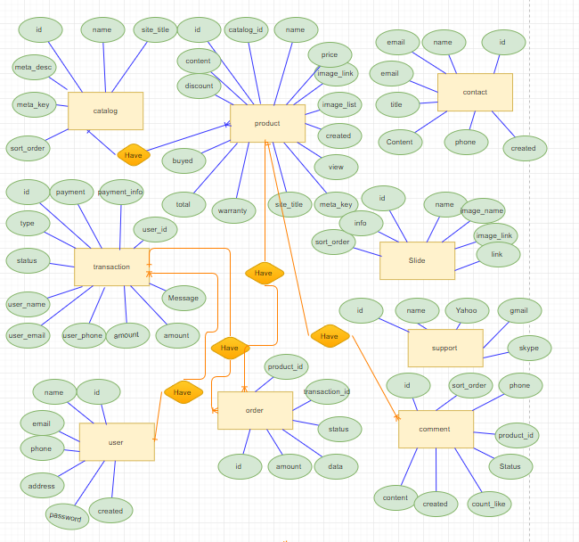

* 1. **Table Relationship Diagram:**

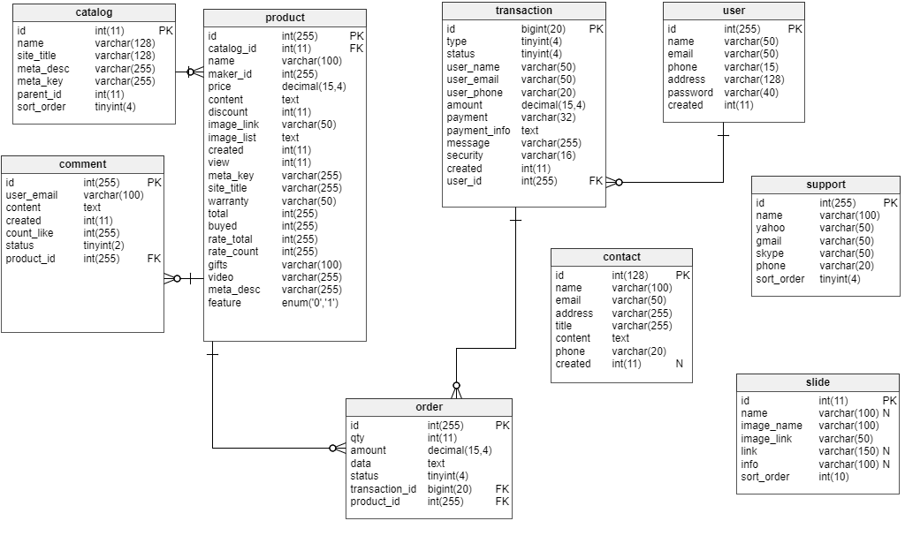

* 1. **Detail**
     1. **Catalog**

**This includes the attribute:**

|  |  |  |  |  |  |
| --- | --- | --- | --- | --- | --- |
| **Attributes** | **Datatype** | **Null** | **Key** | **Default** | **Extra** |
| id | int(11) | not | PK |  | AI |
| name | varchar(128) |  |  |  |  |
| site_title | varchar(128) |  |  |  |  |
| meta_desc | varchar(255) |  |  |  |  |
| meta_key | varchar(255) |  |  |  |  |
| sort_order | tinyint(4) |  |  |  |  |

* + 1. **Product**

**This includes the attribute:**

|  |  |  |  |  |  |
| --- | --- | --- | --- | --- | --- |
| **Attributes** | **Datatype** | **Null** | **Key** | **Default** | **Extra** |
| id | int(255) | Not | PK |  | AI |
| catalog_id | int(11) | Not | FK |  |  |
| name | varchar(50) |  |  |  |  |
| price | varchar(50) |  |  |  |  |
| content | varchar(50) |  |  |  |  |
| discount | int(11) |  |  |  |  |
| image_link | varchar(50) |  |  |  |  |
| image_list | varchar(50) |  |  |  |  |
| created | int(11) |  |  |  |  |
| view | int(11) |  |  |  |  |
| meta_key | varchar(255) |  |  |  |  |
| site_title | varchar(255) |  |  |  |  |
| warranty | varchar(50) |  |  |  |  |
| total | int(255) |  |  |  |  |
| buyed | int(255) |  |  |  |  |
| rate_total | int(255) |  |  |  |  |
| rate_count | int(255) |  |  |  |  |

* + 1. **Transaction**

**This includes the attribute:**

|  |  |  |  |  |  |
| --- | --- | --- | --- | --- | --- |
| **Attributes** | **Datatype** | **Null** | **Key** | **Default** | **Extra** |
| id | Int(11) | Not | PK |  | AI |
| type | tinyint(4) |  |  |  |  |
| status | tinyint(4) |  |  |  |  |
| user_name | varchar(50) |  |  |  |  |
| user_email | varchar(50) |  |  |  |  |
| user_phone | varchar(50) |  |  |  |  |
| amount | decimal(15,4) |  |  |  |  |
| payment | varchar(32) |  |  |  |  |
| payment_info | text |  |  |  |  |
| Message | varchar(32) |  |  |  |  |
| security | varchar(32) |  |  |  |  |
| created | int(11) |  |  |  |  |
| user_id | int(11) | Not | FK |  |  |

* + 1. **User**

**This includes the attribute:**

|  |  |  |  |  |  |
| --- | --- | --- | --- | --- | --- |
| **Attributes** | **Datatype** | **Null** | **Key** | **Default** | **Extra** |
| id | Int(11) | Not | PK |  | AI |
| name | varchar(50) |  |  |  |  |
| email | varchar(50) |  |  |  |  |
| phone | varchar(50) |  |  |  |  |
| address | varchar(50) |  |  |  |  |
| password | varchar(50) |  |  |  |  |
| created | int(11) |  |  |  |  |

* + 1. **Order**

**This includes the attribute:**

|  |  |  |  |  |  |
| --- | --- | --- | --- | --- | --- |
| **Attributes** | **Datatype** | **Null** | **Key** | **Default** | **Extra** |
| id | int(255) | Not | PK |  | AI |
| amount | decimal(15,4) |  |  |  |  |
| data | Text |  |  |  |  |
| status | tinyint(4) |  |  |  |  |
| transaction_id | Int(11) | not | FK |  |  |
| product_id | Int(11) | not | FK |  |  |

* + 1. **Comment**

**This includes the attribute:**

|  |  |  |  |  |  |
| --- | --- | --- | --- | --- | --- |
| **Attributes** | **Datatype** | **Null** | **Key** | **Default** | **Extra** |
| id | Int(11) | Not | PK |  | AI |
| content | Text |  |  |  |  |
| created | Int(11) |  |  |  |  |
| count_like | int(255) |  |  |  |  |
| Status | int(255) |  |  |  |  |
| product_id | int(255) | not | FK |  |  |

* + 1. **Support**

**This includes the attribute:**

|  |  |  |  |  |  |
| --- | --- | --- | --- | --- | --- |
| **Attributes** | **Datatype** | **Null** | **Key** | **Default** | **Extra** |
| id | int(255) | Not | PK |  | AI |
| name | varchar(100) |  |  |  |  |
| Yahoo | varchar(100) |  |  |  |  |
| gmail | varchar(100) |  |  |  |  |
| skype | varchar(100) |  |  |  |  |
| phone | varchar(100) |  |  |  |  |
| sort_order | Int(11) |  |  |  |  |

* + 1. **Slide**

**This includes the attribute:**

|  |  |  |  |  |  |
| --- | --- | --- | --- | --- | --- |
| **Attributes** | **Datatype** | **Null** | **Key** | **Default** | **Extra** |
| id | int(11) | Not | PK |  | AI |
| name | varchar(100) |  |  |  |  |
| image_name | varchar(100) |  |  |  |  |
| image_link | varchar(100) |  |  |  |  |
| link | varchar(100) |  |  |  |  |
| info | varchar(100) |  |  |  |  |
| sort_order | int(10) |  |  |  |  |

* + 1. **Contact**

**This includes the attribute:**

|  |  |  |  |  |  |
| --- | --- | --- | --- | --- | --- |
| **Attributes** | **Datatype** | **Null** | **Key** | **Default** | **Extra** |
| id | int(11) | Not | PK |  | AI |
| name | varchar(100) |  |  |  |  |
| email | varchar(100) |  |  |  |  |
| address | varchar(100) |  |  |  |  |
| title | varchar(100) |  |  |  |  |
| Content | Text |  |  |  |  |
| phone | varchar(50) |  |  |  |  |
| created | Int(11) |  |  |  |  |